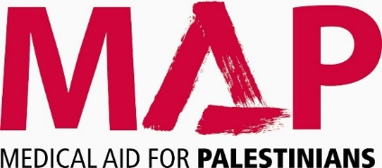

Gift Aid Form

Boost your donation by 25p for every £1 you donate with Gift Aid.

I am a UK taxpayer and would like to Gift Aid this donation and any donations I have made in the past four years or make in the future to Medical Aid for Palestinians. I understand that if I pay less Income Tax and/or Capital Gains Tax each year (6 April to 5 April) than the amount of Gift Aid claimed on all my donations it is my responsibility to pay any difference.

Title: |  | First Name/ Initials: |  | Surname:
Address:

Postcode:

Signature |  | Date

Ref:

Please notify MAP if you want to cancel this declaration, change your name or home address, or no longer pay sufficient tax on your income and/or capital gains.

If you pay Income Tax at the higher or additional rate and want to receive the additional tax relief due to you, you must include all your Gift Aid donations on your self-assessment tax return or ask HM Revenue and Customs to adjust your tax code.

