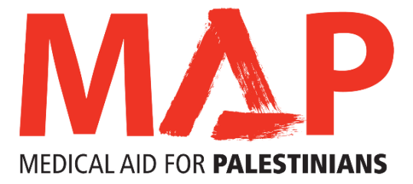

**JOB DESCRIPTION**

|  |  |
| --- | --- |
| **Job Title** | Programme Officer |
| **Location** | Gaza |
| **Mission** | Medical Aid for Palestinians (MAP) works for the health and dignity of Palestinians living under occupation and as refugees. MAP is the leading UK charity delivering health and medical care to those worst affected by conflict, occupation and displacement, in the occupied Palestinian territory and Lebanon |
| **Job Purpose**  **Hours**  **Salary** | To support the implementation and monitoring of MAP’s projects in Gaza in accordance with organisational priorities  Full Time  ILS 94,512 |
| **Reporting to** | Emergency and Complex Hospital Care (ECHC) Programme Manager |
| **Responsible for**  **Internal relationships**  **Contract** | NA  ECHC Programme Manager, Senior Programme Manager, Programme Officers, Programme Assistants, Procurement Department, Finance Department, and Director of Gaza  Permanent |

This job description does not form part of your contract of employment and can be amended from time to time as the needs of the organisation require.

**Duties and key responsibilities**

**Implementation and M&E**

* Under the supervision of the programme manager, support the development of new concept notes/proposals for projects in design phase including assessments, other related project items (logframes, implementation plans, MoUs, database, budgets, etc).
* Under the direction of the programme manager, support the implementation of projects within the ECHC programme portfolio
* Monitor, review and report on the progress of the projects assigned, including narrative and financial reporting
* Regularly engage with MoH relevant departments/units and partners to follow up implemented actions
* Liaise with MAP’s Programme Assistants on related logistics and access arrangements

**Coordination**

* Coordinate preparation for missions of foreign health teams to Gaza with the MoH, hospital administrators and medical personnel at selected hospitals
* Under supervision and oversight from the programme manager, arrange for field visits of visitors, missions, donor representatives, MAP members and others as required
* Establish and maintain strong relationships with key local actors, including, partners, MoH, and committees to facilitate and strengthen networks

**Other duties**

* Work with MoH departments and partners to identify and prepare success stories, videos, photos and case studies in line with MAP’s requirements
* Support fundraising and communication related activities as requested. This may include; case studies, photography, translation for UK colleagues during their visits to the field, etc.
* Represent MAP in meetings and forums as and when needed
* Perform any other reasonable duties that are deemed necessary as assigned by the direct line manager.
* Participate in any emergency interventions when needed

**General Responsibilities**

* Support the mission, ethos and values of MAP.
* Carry out other associated duties as may arise in line with the broad remit of the position.
* Support and promote diversity and equality of opportunity in the workplace.
* Work collaboratively with others in all aspects of our work.
* Represent and be an ambassador for MAP.
* Be flexible and carry out other associated duties as may arise, develop or be assigned in line with the broad remit of the position.
* Maintain and improve competencies through continuous professional development.
* Abide by organisational policies, codes of conduct and practices.
* Treat with confidentiality any personal, private or sensitive information about individual organisations and or clients or staff and MAP data.

**PERSON SPECIFICATION**

**Experience**

* Demonstrated experience of at least 3 years working with INGOs/NGOs particularly health related organisations in a similar position
* Experience in project management, logical framework design, M&E tools
* Familiarity and experience with working with several stakeholders and partners (governmental, non-governmental, CBOs) is desirable

**Skills and abilities**

* Open minded, self-controlled, self-learner and flexible
* Ability to manage budgets, understand financial accountability procedures, and logistics
* Planning, assessment and analytical skills
* Organised self-starter, able to work alone or as part of a team
* Ability to work under pressure and under difficult circumstances and occasionally during the weekend
* Diplomatic and sensitive to cross-cultural issues
* Respect/follow the applied security guidelines and keep the confidentiality of assigned tasks

**Knowledge**

* Excellent reporting skills both narratively and financially
* Excellent communication skills in English and Arabic
* Very good IT skills including excel and spreadsheets

**Education/training**

* A university degree in any health related field

**Personal attributes and other requirements**

* Tact, polite, and able to handle difficult situations and solve problem
* Understand the work of MAP and commitment to our mission and services