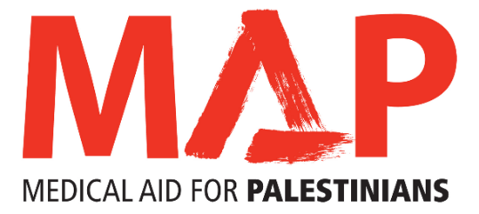

Role | Trustee (with HR Focus)
Location | 33a, Islington Park Street, London, N1 1QB
Mission | Medical Aid for Palestinians (MAP) works for the health and dignity of Palestinians living under occupation and as refugees. MAP is the leading UK charity delivering health and medical care to those worst affected by conflict, occupation and displacement, in the occupied Palestinian territory and Lebanon.
Remuneration | Voluntary
Reporting to | Board of Trustees

Being a Trustee of MAP is an exciting and fulfilling role. The most effective Boards benefit from individuals from a diverse range of backgrounds, experiences and skill sets. We are looking for new Trustee with skills and experience in Human Resources/ Employment Law.
Purpose of the role:
To be responsible as part of the Board of Trustees for the overall governance and strategic direction of the charity, developing the organisation’s aims, objectives and goals in accordance with the governing document and legal and regulatory guidelines.
Main duties:
- To ensure MAP complies with its governing document, charity law, company law and any other relevant legislation or regulations
- To contribute actively to the Board of Trustee’s role of giving firm strategic direction to the organisation, setting overall policy, defining goals, setting targets and evaluating performance against agreed targets
- To safeguard the good name and values of MAP and ensure the effective and efficient administration of the organisation
- To ensure the financial stability of the charity and proper investment of the charity's funds
- To appoint and support the Chief Executive Officer and monitor her or his performance

The Trustee with HR responsibilities takes on additional responsibilities to include:

- Being committed to ensuring highest standards of governance in policies and practice related to employee relations, recruitment, retention, reward and recognition for staff
- Be responsible for staff and trustee training and development.
- To review and recommend current and future strategic direction and resourcing in HR areas.
- Assess risks and measuring the impact of HR interventions in the light of changing legal requirements and best practice.
- To actively contribute as required to policy setting, strategic direction, goal and target setting, and evaluate performance against targets, budgets, plans and charitable objectives.
- To ensure that HR activities and interventions are linked to the MAP’s objectives and complement MAP’s culture.

Other duties:

- To be an ambassador and advocate for MAP
- To be willing and able to use any specific knowledge or experience to help the Board of Trustees reach sound decisions
- To follow MAP’s code of conduct and current best practice on being a Trustee
- To be an active member of the Trustee body in exercising its responsibilities and functions, and attend meetings faithfully

Person specification

Experience:

- Skills and expertise in employment law or FCIPD qualified, with unionised charity experience is desirable
- Demonstrable experience of building and sustaining relationships with key stakeholders and colleagues to achieve organisational objectives
- A proven track record of sound judgement and effective decision making
- A track record of applying DEI lens to MAP policies

Knowledge, skills and understanding:

- Strong empathy with MAP’s mission to work for the health and dignity of Palestinians living under occupation and as refugees
- A willingness to devote the necessary time and effort
- Good, independent judgement and strategic vision
- An understanding and acceptance of the legal duties, responsibilities and liabilities of trusteeship
- An ability to work effectively as a member of a team
- Knowledge, understanding and understanding of the political context and of development and humanitarian issues in Palestine and Lebanon and the wider Middle East.
- An understanding of the respective roles of the Chair, Trustees and Chief Executive

If you feel you can contribute to helping MAP work for the health and dignity of Palestinians living under occupation and as refugees, please send your CV and a covering letter explaining why you want to join us as a Trustee and what skills and experience you can bring to hr@map-uk.org. Deadline: 13 October 2021

