

Assessment of the Neurosurgical services in Gaza and proposal for support

MAP-UK

Assessment team:

Sir Terence English
Professor Terence Hope
Mr. John Beavis
Ms. Sara Halimah

Table of Contents
EXECUTIVE SUMMARY 3
INTRODUCTION 4
BACKGROUND 4
CURRENT STATUS AND ANALYSIS 5
CAPACITY AND COORDINATION OF THE NEUROSURGICAL UNITS 5
SPECTRUM OF NEUROSURGERY IN GAZA AND REFERRALS 6
EDUCATION AND TRAINING 7
RESIDENCY TRAINING PROGRAMME 8
MULTIDISCPLINARY TEAM WORK 8
NEURO-ANEASTHESIA 10
INTENSIVE CARE UNITS 11
NEURO TRAUMA 12
OUTPATIENT CLINICS 12
MEDICAL EQUIPMENT 13
PREVIOUS INTERNATIONAL SUPPORT 14
SUGGESTED SUPPORT 14
FELLOWSHIPS AND TRAINING OPPORTUNITIES 14
RESIDENCY TRAINING OPPORTUNITIES OUTSIDE GAZA 14
VISITING MEDICAL TEAMS: ON-JOB TRAINING AND SEMINARS 15
EQUIPMENT 15
INTERNATIONAL NEUROSURGERY WORKSHOP 15
EXPECTED OUTCOMES 15
OTHER REQUIREMENTS 16
CONCLUSION 17

EXECUTIVE SUMMARY

The ongoing conflict has left many Palestinians with head injuries and complex spinal cord injuries; this coupled with an increasing trauma from road accidents has placed a huge strain on neurosurgery in Gaza.

In August 2015, Sir Terence English and Professor Terence Hope with support from Mr John Beavis and Sara Halimah led an assessment of the quality of neurosurgical services in Gaza, which are based at the Al Shifa Hospital and European Gaza Hospital. The purpose of the assessment was to identify the key gaps in the service and to propose a programme of support.

The key findings of the report found:

- A lack of trained personnel. There are only 2 recognized consultants in neurosurgery in the entire Gaza strip. The consultants lead a team of neurosurgeons who have undertaken some training/ fellowship opportunities abroad but have no formal qualification in neurosurgery.
- A lack of multidisciplinary team. The EGH had a suitable multidisciplinary team but even so there were no neuro-trained nurses and only one neuro-aneasthetist in all of Gaza.
- Well-equipped facilities. The two-neurosurgical units in Gaza are both are well equipped.
- No residency-training programme. There is no residency-training programme for neurosurgery in Gaza.
- Complex cases referred outside Gaza. Neurosurgeons lack the skills to conduct complex neurosurgery and often refer complex cases outside of Gaza, potentially compromising the safety and surgical outcome of the patient.
- Gaps in neuro-rehabilitation. There are no neuro-physiotherapists at Al Shifa Hospital, in contrast to EGH where there is a dedicated physiotherapy team.
- Poor A&E referral. Head injuries are not referred quickly from the A&E to the neurosurgical units.
- Staff shortages in intensive care units (ICUs). The ICUs at both hospitals are well equipped but lack staff; there is a shortage of nurses and particularly senior nurses.

With support from a dedicated group of well-known British neurosurgeons, MAP is proposing to implement a three-year training programme for neurosurgery. The aim of the programme will be to build the capacity of the staff working at the neurosurgical units. This will involve some or all of the following components:

- Fellowships and training opportunities:
- 6-week fellowships to teams of doctors, nurses, physiotherapists and anesthetists from Gaza to come and train in the UK.
- MAP will select two junior doctors and train them to become consultants.

- Sending UK neurosurgeons to Gaza:
- UK neurosurgeons will visit Gaza and work side-by-side with the neurosurgeons in Gaza.

- Equipment procurement:
- There is an essential need for specific items such as intracranial pressure monitors ICPs (including the consumables) and blood gas machines. MAP hopes to supply some of the necessary essential equipment.

- International Neurosurgery Workshop in Gaza:
- Gazans do not have the opportunity to take part in medical conferences abroad; MAP, led by the local neurosurgeons will explore the possibility of organizing an ‘International Neurosurgery Workshop’ in Gaza with the presence of British neurosurgeons.

INTRODUCTION

The specialty of neurosurgery involves the clinical management of patients with surgical conditions of the central (intracranial and spinal) and peripheral nervous system. It is particularly subject to; high levels of emergency/urgent work and very rapid and technological change. Neurosurgery developed late among surgical specialists.

For countries where there is ongoing conflict and in Gaza where recent attacks have resulted in high numbers of severe head trauma and spinal cord injuries, the need to develop the neurosurgical services is essential. Without the appropriate surgical management these trauma cases will result in high mortality and morbidity.

In August 2015 Medical Aid for Palestinians (MAP UK) sent a team to the Gaza Strip to assess the quality of neurosurgical services in the Ministry of Health (MoH), this report highlights the key findings of the assessment team. The key objective of the report is principally to highlight the strengths and weaknesses in neurosurgery in Gaza; and second, to offer feasible and measurable means of supporting the development of neurosurgery for the long term by working in partnership with the MoH.

BACKGROUND

Neurosurgery in Gaza was recognized as a medical specialty in 2011. Its late development was not a result of the lack of need, but rather due to a lack of facilities and human resource. Since then, neurosurgery in Gaza has come a long way, with the establishment of 3 recognised neurosurgical units in the Gaza Strip. One is based at the European Gaza Hospital (EGH) and two at Al Shifa hospital.

Those involved in clinical neurosurgery have worked hard to develop and maintain the reputation of neurosurgery in Gaza. Many of the standards achieved have been the result of rigorous self-regulation in the belief that this is in the patient`s best interests.

However, neurosurgery, like many of the other medical specialties in Gaza, is facing challenges that severely limit the MoH’s ability to develop the service. In many cases, these factors are beyond the control of the MoH. They present obvious limitations to everyday life as a neurosurgeon in Gaza- this is as result, both directly and indirectly, of the Israeli occupation. These include a lack of postgraduate and more specialized training opportunities, which have hampered the development of the specialty, and, more generally, problems of ensuring the quality and safety of care and the maintenance of appropriate standards.

The older, senior doctors were all trained abroad in many different countries (including the UK) and to varying standards before medical schools were established in occupied Palestine. This compounds the difficulties of ensuring consistency of clinical standards and practice.

The lack of training opportunities has resulted in a health system that is reliant on referrals outside of Gaza, particularly for complex and costly cases. This has particularly been the case for neurosurgery cases. For example, in neurosurgery, there is no cervical spine surgery nor surgery on pituitary tumours (trans-spenoidal) currently being conducted in Gaza; all these cases are being referred outside of Gaza. The referral system is not only very costly to the MoH; but in addition to the added financial burden, the patients health is put at great risk because any referrals require Israeli-issued permits to travel outside of Gaza, which are commonly delayed or rejected.

During the recent 51- day Israeli assault on Gaza, there was an increase in medical referrals in which there was a great need for neurosurgeons, particularly specialists in spinal cord injury. In fact, during the assault the MoH requested support from international neurosurgeons to come to Gaza and support the local neurosurgeons.

CURRENT STATUS AND ANALYSIS

The three-neurosurgical units in Gaza serve a population of 1.82 million. Although Al Shifa Hospital has two units, in practice the units work together in rotation, increasing the number of patients that can be seen each week. For this reason, the analysis and overall assessment of the two units in Al Shifa will be reviewed together.

CAPACITY AND COORDINATION OF THE NEUROSURGICAL UNITS

In neurosurgery, a good axiom is ‘good facilities lead to good outcomes`.

In the Al Shifa hospital where Dr Usama Aklouk and Dr Basil Bakr manage the two-neurosurgical units there are dedicated neurosurgical staff. Dr Usama is the official head of the units and takes overall management responsibility. Each head is supported by 2 specialist neurosurgeons. Specialists have had many extensive years of experience in neurosurgery and have undertaken a fellowship outside of Gaza. In addition, there are 4 residents supporting the units at Al Shifa Hospital. The neurosurgical team in Al Shifa is well organized and their skill set is equally distributed between the two units.

Unfortunately the ICU unit is not located in close proximity to the neurosurgical ward. Close proximity between ICU and neurosurgical ward is generally ideal given the nature of neurosurgery and particularly the increased number of head injury cases in Gaza.

In the EGH, the neurosurgical team comprises of the head of the unit, Dr Nidal Abuhadrous, 4 specialists and a number of residents. The team is well equipped to deal with the needs of the patient. In terms of proximity to other facilities, it is appropriately located next to the ICU.

The caseload varies enormously between the two units, with Al Shifa taking on the bulk of neurosurgical cases. This is somewhat expected as Al Shifa is the main trauma hospital in Gaza and is located centrally within the Gaza Strip. However, it seems that at times the neurosurgical unit in Al Shifa Hospital does not have the capacity to cope with the influx of patients. Unfortunately, there is no caseload sharing across the two units.

The lack of coordination, communication and patient referrals between the two units will hinder any progress in developing neurosurgery in Gaza. It is essential that the neurosurgical units in the Gaza strip work together and this is achievable.

SPECTRUM OF NEUROSURGERY IN GAZA AND REFERRALS

The strain on the neurosurgical units in Gaza is also a result of the increasing number of neuro-trauma cases being admitted to the hospital. The vast majority of cases are spinal cord injuries or head traumas. This is either a direct result of ongoing conflict, or from non-war related accidents around Gaza (such as road traffic accidents). The most telling picture that has emerged is the almost exclusive concentration of trauma and emergency work at the units, often at the expense of the waiting lists. In fact, non-urgent or non-life threatening cases are placed on a 6-month waiting list and can face substantial delays even when the treatment is due.

With the increasing demand for trauma work in the last five years, there is also a concern of covert rationing. A substantial number of patients are discharged too early in order to make room for new cases; for example, patients with spinal contusion or compression have been discharged within 3 days of surgery.

It is clear that the neurosurgeons in Gaza have problems managing the complex head trauma and spinal cord injuries. Therefore patients in Gaza lack confidence in the surgeons and often prefer to be referred outside of Gaza, even knowing the likelihood of delays and visa restrictions.

Simultaneously, local neurosurgeons are also too risk averse and are reluctant to convince patients to stay in Gaza. The reason for this is two fold; any post-operation complications may place the surgeon’s licence at risk, as there is no medical insurance provided by the MoH and secondly, (almost as a knock on effect) the ability for local neurosurgeons to perform complex cases is diminishing. A lack of training opportunities or refresher courses further adds to this.

The need for complex neurosurgery has increased but this has not resulted in increased clinical practice because the majority of complex cases are being referred outside of Gaza.

Referring patients outside of Gaza leads to problems for local doctors, as both hospitals reported that patients often return with complications and post-surgical infections. These need careful follow up and treatment, in turn are placing a further strain on the neurosurgical units.

It is worth noting that this has also been MAP’s experience working in other medical specialities in Gaza, and neurosurgery is not unique in this regard.

EDUCATION AND TRAINING

The mistrust of doctors by the patients is both a symptom and a cause of the lack of training opportunities available to the neurosurgeons. Without training to upgrade skills and little or no practice of complex neurosurgical cases, the quality of care in neurosurgery will decrease.

There are currently only 2 Board certified general neurosurgeons in the whole of the Gaza Strip. These Neurosurgeons received their training outside of Gaza, prior to the blockade and the restrictions on access. There are no opportunities to sub-specialize within Gaza. Currently all practicing neurosurgeons are general neurosurgeons.

Furthermore, there are no training opportunities to update or even maintain the skills of the trained consultants working in Gaza. For example, Dr Nidal Abuhadrous undertook his training in Qatar and has since then not utilized all of his skills and knowledge. On one particular occasion he explained that 6 Intracranial Pressure Devices (ICP) were provided to EGH but they have not been used because patients do not have confidence in the surgeons and do not give permission for their insertion, regarding it as ‘experimental`. Since he has not practiced this upon returning to Gaza he would need to be re-trained before being able to confidently perform it himself.

Gradually the opportunity for the neurosurgeons to maintain their clinical knowledge and improve their skills to meet international standards continues to decline. This in turn, leads to a lack of confidence from their patients and increases requests for referrals outside the region.

Training/refresher courses for neurosurgeons and their teams must be prioritized so that they can maintain and upgrade their clinical knowledge to meet the needs of the population.

RESIDENCY TRAINING PROGRAMME

One of the most pressing issues raised was the lack of a residency-training programme in Gaza. Many of the trained specialists are not able to qualify as consultants and young residents interested in becoming neurosurgeons have no access to a residency training programme. As a result, many young residents drop out and choose to specialize in other medical areas where there is a proven training programme.

In 2011 a training programme was submitted to the Palestine Medical Council, which included a joint proposal by Gaza and the West Bank/East Jerusalem led by Dr Nidal Abuhadrous, Dr Usama Aklouk and Dr Jamal Gosheh from Al Makassed Hospital in East Jerusalem. Upon analysis, the training proposal was a strong proposal but unfortunately it was rejected.

Since then, there has been no further development of the residency training programme and the breakdown in communication between Gaza officials and the West Bank has put a halt to this initiative. The West Bank now has an approved training programme for neurosurgeons led by Dr Jamal Ghosheh; the Gazan surgeons have pushed for their own recognised residency-training programme for neurosurgery in Gaza but to no avail.

The Palestinian Medical Board rejected Gaza’s training programme on the basis that the number of consultants in Gaza is insufficient to lead the training programme. However, with external support and international neurosurgeons supporting the training, there would be a case for resubmitting the training proposal to the Palestinian Medical Council.

Recognising these challenges, MAP would strongly encourage neurosurgeons in Gaza to work towards building a recognized neurosurgery-training programme. Importantly MAP would encourage better communication between the neurosurgical units in Gaza and in the West Bank/ East Jerusalem. MAP recognizes the barriers to achieving this, but a good relationship between the neurosurgical units in Gaza and the West Bank/ EJ, will greatly benefit the development and recognition of neurosurgery in Gaza.

Furthermore, there may be training opportunities, conferences and medical educational events in the West Bank and East Jerusalem that could be useful for Gaza’s neurosurgeons to attend.

MULTIDISCPLINARY TEAM WORK

An effective neurosurgical team must be a multi-disciplinary team and workforce planning should reflect this.

Visiting the EGH neurosurgical team, we were impressed by the teamwork approach in patient diagnoses, treatment and care. They had dedicated nurses (although not formally trained as neuro-nurses) and dedicated specialist neuro-physiotherapists. The level of communication between the team members was evident and this was clearly reflected good quality as regards patient diagnosis.

We were extremely pleased to hear that the neuro-physiotherapists working at the EGH were also offering on-job training for up to 3 months for newly graduated physiotherapists across Gaza.

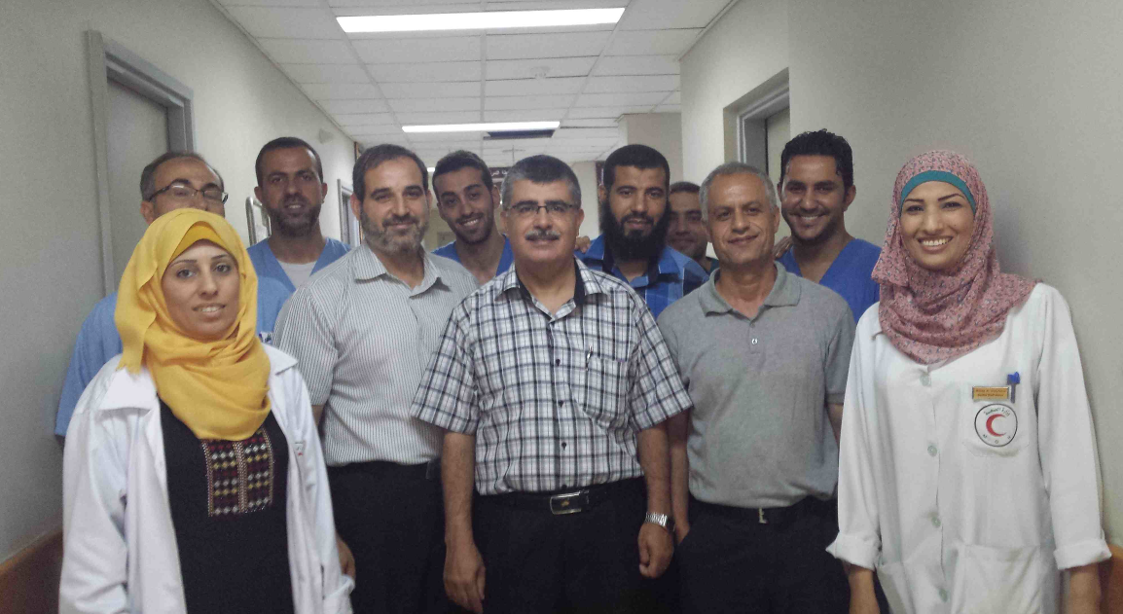

Photograph: Dr Nidal Abuhadrous (head of the EGH) and his team of neurosurgeons, nurses and neuro-physiotherapists.

Unfortunately, this is in stark contrast to Al Shifa where there were no dedicated or appropriately trained neuro-nurses and physiotherapists.

We also met with the Head of the Rehabilitation Unit in the MoH, Ayman Halabi. He explained that there is limited discussion between the members of the rehabilitation team and their medical colleagues, which negatively affects the health and recovery of the population.

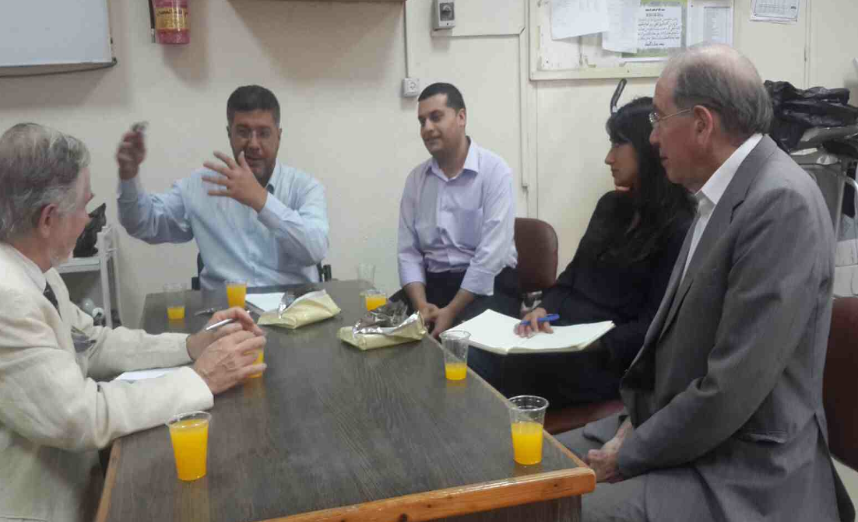
The assessment team meet Ayman Halabi, Head of the Rehabilitation Unit in the MoH, at the outpatient physiotherapists facilities in Al Shifa Hospital.

MAP strongly recommends that at Al Shifa neurosurgical unit has:

- Appropriately trained and committed neuro-nurses

- Physiotherapists experienced in specialist care available as required

- Doctors that produce detailed discharge notes and refer patients for physiotherapy in a timely manner

NEURO-ANEASTHESIA

Any effective multidisciplinary team must include well-trained and specialized anesthetists.

We met with Dr Hisham Zanati, the only trained neuro-anesthestist in Gaza and now working at Al Shifa Hospital. Dr Hisham Zanati is also the head of training for anesthesia in Gaza.
Dr Hisham explained that the majority of neurosurgery conducted in Gaza were simple operations and the complex cases were referred outside of Gaza. Therefore the level of surgery in Gaza is currently not sufficiently complicated enough to warrant more neuro-aneasthetists. This is particularly the case for the EGH were the amount of complex neurosurgery is small.

The current anesthesiology-training programme includes only 3 months of on-job training in neuro-anesthesia. Dr Hisham Zanati confirmed that if the number of complex neurosurgical operations increased there would be an incentive for training more neuro-anesthetists in Gaza.

Dr Hisham also highlighted shortages in essential equipment for neuroaneasthesia, for example there are no arterial lines (for blood pressure monitoring) and no transducers to attach.
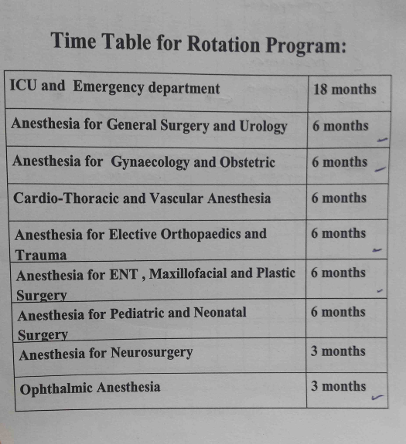
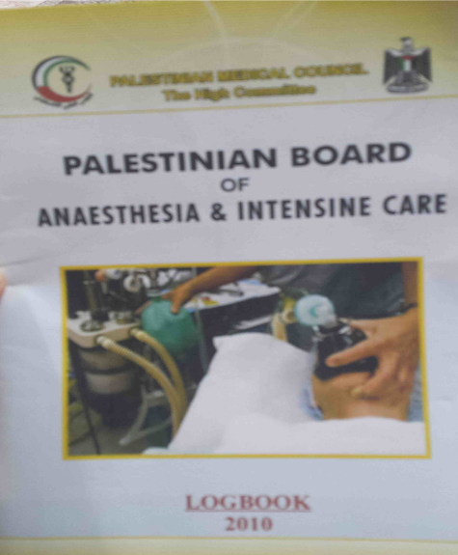

Photograph: the anesthetist training log-book. Notably, only 3 months are spent on neuro-anesthesia.

INTENSIVE CARE UNITS

During our discussion with Dr Hisham it became evident that there was a clear weaknesses in the intensive care units’ (ICUs) capacity, in which notably a large proportion of patients are neurosurgical cases.

No specific training exists for intensivist specialists in Gaza and staffing and training shortages amongst nurses are severe. Furthermore, ICUs across Gaza are non-specialised and care for a highly heterogeneous group of patients. In the context of recurring conflict, ICUs frequently serve as reserve capacity for emergency departments whilst simultaneously receiving a high number of critical cases. Intermediate care units do not currently exist in Gazan hospitals placing a further strain on the ICUs.

Support for ICUs and capacity building for related staff groups would improve patient outcomes for critically ill patients and improve post-surgical care related to other MAP projects.

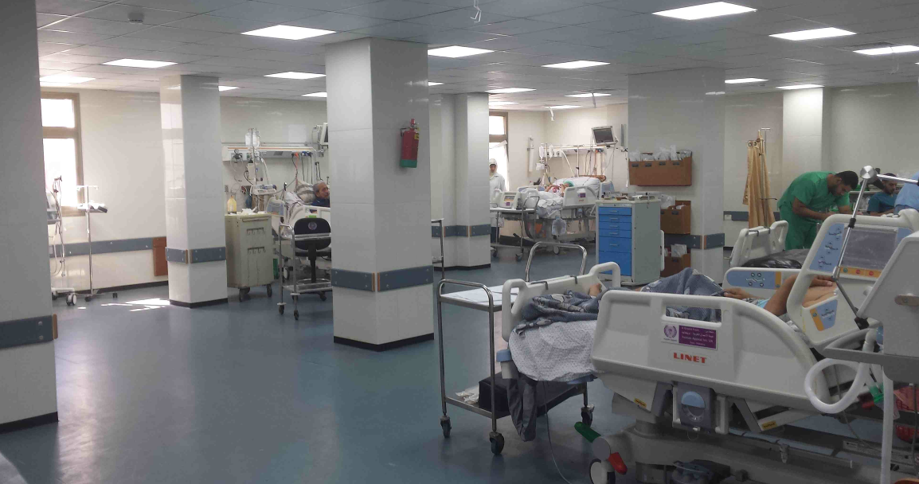

Photograph: The newly refurbished ICU in Al Shifa Hospital (now located in the New Surgical Building). It is well equipped but only has 3 nurses present at a single time and therefore, can only accommodate for a maximum of 3-4 patients.

NEURO TRAUMA

As noted, a large number of cases treated in the neurosurgical units in Gaza are head trauma and spinal cord injuries. They often arrive first in the Emergency Department and require emergency treatment before being referred to the specialist neurosurgery units. Particularly in cases such as acute spinal compression or severe head injury a decision on transfer ought to be communicated immediately. Unfortunately, in Gaza head injuries are not being referred in time to the neurosurgical units.

OUTPATIENT CLINICS

Both the neurosurgical outpatient units were overstretched, seeing on average 120-140 patients per clinic and often exceeding the number of patients present on the clinic schedule. Each consultant was spending approximately 5 minutes with each patient before deciding the course of treatment, which is not a sufficient length of time.
It is unclear if the majority of cases at the outpatient clinics were self-referral or through other centers, but there is a need to reduce the burden on the hospital services. The neurosurgeons at the Al Shifa and the EGH must educate the referring doctors as to the criteria for being seen and possibly admitted. The neurosurgeons must also work with the physiotherapists during the outpatient clinics to establish the criteria for outpatient physiotherapy. This will significantly reduce the burden on the outpatient clinics and is achievable within the timeframe of MAP’s programme.

MEDICAL EQUIPMENT

Both units in Gaza are relatively well equipped having received equipment from various international donors. The neurosurgical unit at the EGH was fully equipped 5 years ago and includes all the essential medical instruments. This includes; neuro-navigation (otherwise known as frameless stereotaxy) and all the equipment for neuro-endoscopy, and neuro-stimulation. However, much of this equipment is specialized and it is of little use at present.

As with other services, electricity shortages place a strain on the use of essential neurosurgery medical equipment. This was particularly the case at the EGH. The CT scanner was regularly out of use for 3 hours a day because the generators could not run during power cuts. Patients were moved to another hospital for CT with consequent delay (usually in emergency head injury cases).

Angiography (which is a basic technique in neurosurgical imaging) does not exist, but as such vascular cases would be referred outside.

Al Shifa hospital is in a similar position with all the necessary equipment including 2 C-T scanners but little or no training in the use of some of it.

Both units also suffer from a depletion of essential consumables. For example, at the EGH, ICP was available but Codman catheters had expired and since then had not been replaced leaving the ICP equipment now redundant.

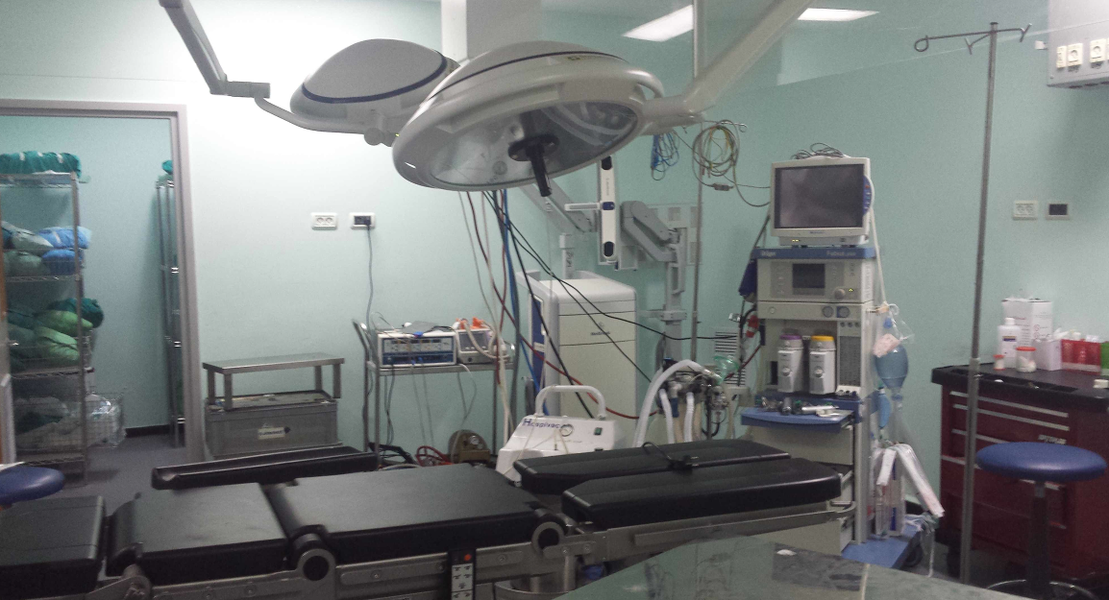
Photograph showing facilities at the EGH neurosurgical unit

PREVIOUS INTERNATIONAL SUPPORT

In discussions with the MoH, it was clear that foreign teams of neurosurgeons and their non-physician staff have come to Gaza to support the neurosurgical units. This has particularly been the case since the Israeli assault last summer, in 2014. However, there was little consultation with service the local teams and no training opportunities offered as part of the mission. In some cases, the motive seems partly to have been for teams to gain experience in severe complex trauma cases. This led to frustration and a sense of lack of autonomy amongst the local staff.

Any programme of support should involve mutual communication from all those involved and agreed principles of operation and objectives set before visits take place.

SUGGESTED SUPPORT

The following programme of support is recommended to strengthen neurosurgery in Gaza.

FELLOWSHIPS AND TRAINING OPPORTUNITIES

The blockade in Gaza presents huge challenges for health professionals as their ability to upgrade their skills and undertake training is severely limited. Fellowships will give essential staff working in the neurosurgical units with an opportunity to improve their skills and to experience and understand the management systems in place in other countries with more advanced health systems and apply what they learn on return to Gaza. Such exposure would also allow the health professionals to fully experience a multidisciplinary setting. Finally, establishing fellowships at hospitals (such as the Nottingham Queens Medical Centre through Professor Terence Hope) enables a long-term faculty relationship to be built between Gaza and the overseas facility.

The length and content of the fellowship will be determined by the needs on the ground and the individual. Fellowships will be offered to a team of neurosurgeons, anesthetists, nurses and physiotherapists, thereby reinforcing the multidisciplinary approach.

RESIDENCY TRAINING OPPORTUNITIES OUTSIDE GAZA

The lack of an adequate residency programme in neurosurgery has hindered its development. Furthermore, it has prevented young trainee doctors to consider neurosurgery as a specialty in medicine; young doctors who initially show an interest tend to move towards those specialists, which are already established. In the near future, once the current consultants retire, neurosurgery in Gaza will decline if there is no investment in its young potential neurosurgeons. MAP hopes to support the training of 2 residents to undertake their full specialization. The selected individuals will undertake their training for a period of 2 years outside of Gaza; this may be in East Jerusalem, Jordan, Lebanon or the UK.

VISITING MEDICAL TEAMS: ON-JOB TRAINING AND SEMINARS

Once the fellows have returned to Gaza after completing their time in the UK, shortly afterwards MAP will enable UK neurosurgeons to work side-by-side with the local staff in Gaza (this will be used to test their application of knowledge upon returning from their fellowship).
The patients will benefit from improved outcomes thanks to direct surgical intervention from UK neurosurgeons and from the improved surgical capacity of the local neurosurgeons.
This will take place through visiting medical teams throughout the year and each medical mission will last between 1 – 2 weeks. Medical teams will comprise of:
- Seminars for in-house training on selected topics for example intracranial pressure monitoring ICP
- Outpatient clinics
- Theatre sessions
- Wards rounds
Visiting neurosurgeons working alongside local medical staff in Gaza throughout the assessment, treatment and follow-up of surgical patients, training and transfering their skills to Gaza’s doctors, so that they are able to perform more complex operations independently. This is vital for ensuring that Gaza’s hospitals are able to treat all patients in need of neurosurgery.

EQUIPMENT

The majority of essential equipment necessary for neurosurgery is already present in the two units in Gaza. However, there is a need for specific items such as intracranial pressure monitors ICPs (including the consumables) and blood gas machines. MAP plans to identify a small list of essential needed equipment. Alongside the provision of the equipment, the local staff will be trained on its use. This will take place during the medical missions.

INTERNATIONAL NEUROSURGERY WORKSHOP

One of the key factors that is inhibiting the development of neurosurgery in Gaza is the lack of recognition by the PMB. MAP would like to explore the possibility of supporting the MoH in organizing an ‘International Neurosurgery Workshop’ in Gaza, which should be led by the local neurosurgeons. The aim of this is to bring together neurosurgeons, and other doctors, nurses and health professionals, to review new ideas and areas for improved collaboration. It will also be an opportunity to discuss other issues such as the burden on outpatient clinics and define clear referral standards for local doctors. The workshop/conference will also be supported by the presence of international neurosurgeons. It will hopefully attract local and international media attention.

EXPECTED OUTCOMES

It is hopes that this programme will achieve five key improvements in standards of practice:

- Improved patient assessment procedures: Through the workshops and seminars and outpatient clinics, the overseas neurosurgeons will help to improve the skills of local surgeons in diagnosing medical problems related to neurosurgery.

- Improved planning of treatment: The education workshops and seminars and outpatient clinics will improve treatment and diagnoses.

- Patient-focused approach: The outpatient clinics will attempt to shift the focus of patient interaction from the specialist to the patient by ensuring that the specialists discuss the diagnosis and treatment plans with the patient and most importantly reassure patients that treatment is available and it is not necessary to be referred. This approach will increase the likelihood that patients will have faith in the care they are receiving and therefore not elect to interrupt their treatment.

- Increased range of surgical interventions: Both the operative training and the training in the use of equipment will hopefully increase the range of surgical procedures that can be carried out safely in the Gaza Strip.

- Multidisciplinary culture: By bringing together neurosurgeons, nurses and physiotherapists at outpatient clinics, the project will foster links between these specialists and the implementation of multidisciplinary assessment and treatment of patients. This vital step will help to ensure that patients have appropriate treatment at each step and that they have continuity of care.

The offer of fellowships and training opportunities will have a clear impact on the long-term suitability of neurosurgical standards in the Gaza Strip, most notably this will include:

- Investing in future leaders through the residency-training programme: upon returning to Gaza having successfully completed their training, these surgeons will be able to self regulate neurosurgery in Gaza and enhance patient outcome. Second, they will be able to pass on their knowledge and skills to their teams.
- The fellowships will have a similar impact but will be focused on developing clinical skills and on supporting the selected fellows to better understand system change and development.

OTHER REQUIREMENTS

The success of this programme depends crucially on the support of the MoH and of dedicated local staff. These key requirements are:

- Training programmes must be prioritized to maintain the clinical skills of the local neurosurgeons and their staff.
- There must be improved communication and coordination across the two neurosurgical units in Al Shifa Hospital and the European Gaza Hospital.
- The local neurosurgeons should be encouraged wherever possible to re-build a working relationship with the neurosurgeons in the West Bank and East Jerusalem.
- A residency-training programme for neurosurgery in Gaza should be supported. Without Gaza’s own residency training programme, neurosurgery in Gaza will not attract an adequate number of trainees in order to sustain itself as a specialty in the long term. The development of a recognised residency-training programme will not only increase the workforce but also qualify the trained neurosurgeons to undertake recognised training opportunities outside of Gaza.
- A multidisciplinary approach should be promoted, by encouraging its staff to understand that the impact of surgery is limited without the active involvement of nurses, physiotherapists and anesthetists.
- Emergency departments should refer trauma cases, particularly head trauma, more quickly to the necessary specialised units. ICU capacity should also be strengthened

CONCLUSION

The programme outlined above will greatly improve the standard and range of neurosurgery taking place in Gaza and should reduce the number of neurosurgical referrals outside of Gaza.

Patients with urgent, but non-life threatening neurosurgical conditions should be admitted within 48 hours of diagnosis. Patients with painful or disabling conditions that are not life threatening should be seen by a consultant within 2 weeks and then admitted, if admitted it is necessary to be referred to a neurosurgical unit within 6 weeks of the condition being diagnosed. It is not acceptable in clinical terms for patients; with for example, disabling spinal conditions to be expected to wait a year or more for treatment.

