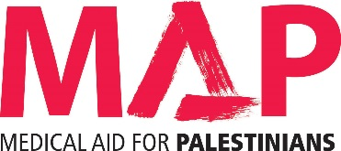

A Review of the Decontamination & Sterilisation Facilities and Infection Control Arrangements at Shifa Hospital, Gaza
Dr Robert C Spencer
MB BS MSc FRCP[G] FRCPath Hon DipHIC
Consultant in Clinical & Environmental Microbiology
November 18 2015

Introduction
Continuing on from the on-going medical support to Gaza, MAP in partnership with IDEALS and NORWAC committed to a programme of support that aimed to establish a multidisciplinary limb reconstructive unit at Shifa Hospital. Through on-job training, education symposia and provision of medical equipment the overall objective is to build the local capacity of managing complex limb reconstruction in order to reduce referrals outside of Gaza; which are costly and often comprise the safety of the patients.
To ensure the success of the limb reconstruction unit (LRT) another important aspect needs to be addressed. This aspect is the infection control measures where the unit in Shifa suffers from shortages of infection control supplies and appropriate sterilization of medical equipment. Infection control has a significant impact of the recovery of limb reconstruction patients.
In light of this, Dr Robert Spencer conducted an assessment of the sterilisation and infection control services in November 2015 with ongoing support in Gaza by Sara Halimah from MAP. The assessment focused on Shifa hospital and assessed two key areas; sterilization services, and general prevention infection control procedures and practices.
Summary of activities/method of assessment
The assessment was based on observations to the key sites and meetings with clinicians and managers at the hospital. Dr Robert Spencer spent some time visiting the central sterilisation unit where he met the key staff, including Naser Hamad Head of Nursing in Theatre and the central sterilisation services unit, and his team. Visits were also made to the central dispensation unit to meet Ishmael Thebet, and also the microbiology lab and the blood bank storage unit.
Meetings were held with various officials are the MoH, including Dr Yousif H. Abu El Reesh, Deputy Minister of Health, Mr Mousa Al Amawi, Head of Infection Prevention Control MoH, Mahmood Uda, Head of Quality Control, Shifa Hospital.
A visit was also made to the sterilisatuion units in the maternity ward and the burns units in Shifa Hospital.

- Sterilisation services at Al Shifa Hospital

Overview of the sterilisation services at Al Shifa Hospital
At Shifa hospital there are sterilisation units in the OR, maternity and burns departments, with a Central Sterilisation Department dealing with everything else (and plastic/rubber re-usable equipment from the departmental units). The MoH had agreed a plan to move all these services, excluding the burns department sterilisation unit (which would remain separate), into the building that housed the old burns department, but we understand this plan has now been abandoned.
Key findings of the sterilisation services at Shifa
OR Sterilisation Unit:
- The OR suite has six operating theatres but only four were functioning at the time of my visits.
- There is no adequate theatre ventilation or temperature control.
- Operating gowns and drapes go to the Nasser Hospital for washing and sterilisation.
- The case load is some 30-40 cases per day; theatre lists arrive either the night before or the morning of the surgery. From 0800 – 1500 each day the sterilisation unit is staffed by 3-4 nurses, with a senior nurse Jamal, who has been working there since 1981. After 1500h the emergency scrub nurse is responsible for the unit in addition to their role in theatre.
- There are no checklists to accompany the instrument trays to theatre and no list to check whether the trays have a full complement of instruments on their return to the unit.
- The area were the sterilised trays of instruments are stored is open access to anyone.
- There is no record for theatre nurses to sign when removing the trays to the operating theatre. The only record as to who has packed the instruments is by writing the name on the strip of Bowie-Dick tape, which accompanies the trays for sterilisation.
- The whole OR set-up is small and the general estate is of poor quality. There is no actual physical separation of dirty, clean, sterile areas with no temperature or humidity control.
- The used instruments are returned form theatre on a trolley with instruments on the top and dirty often blood stained linen on the bottom of the trolley. The instruments are then placed in a sonicator for some 10 minutes at 50oC.
- They change the water and antiseptic solution every 3-5 uses.
- There was no record of planned maintenance or validation of the sonicator.
- The instruments are then hand washed using an antiseptic solution of 1% chlorhexidine and 15% cetrimide. This is not a detergent.
- A modern AT-OS washer-disinfector is in place but cannot be used because of the lack of appropriate enzyme-detergent.
- The quality of water used in the sonicator, hand washing and steam generation is of very poor quality with high salinity content. No water testing appears to be performed.
- The area, where instruments are checked and packed for sterilisation [clean room], is an open thoroughfare.
- They do have access to compressed air to “clean” hinged instruments but I did not observe the use if any lubricant. The instruments appeared old and in poor condition.
- The instruments are linen packed rather than paper. The use of fabric in sterilisation does not aid drying and therefore can lead to rusting when combined with the poor quality of water.
- There is no illuminated magnifying glass to aid instrument inspection.
- The two autoclaves are old [>12 years] and need constant attention from the hospital engineers.
- There is no paper or electronic record as to whether a successful sterilisation cycle has been achieved. No paper for the print out. Storage of the sterilised instrument packs is open access.

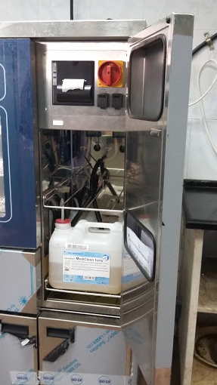

Photo: This is a fairly modern automated washer - disinfector that remains unused because there is no guarantee of the appropriate enzymatic detergent. One of two in Shifa Hospital.

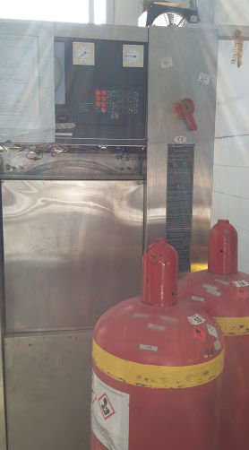

Photo: This is an ethylene oxide steriliser that cannot be used, because Israel will not allow the importation of ethylene oxide under the "dual use " umbrella”.

OR New Building
- Space has been set-aside for a sterilisation unit but is not yet operational. It is small and poorly designed with no physical barriers between the dirty, clean, sterile areas.
Obstetrics and Gynaecology Unit
- This is a small area with no physical barriers. They process some 35 trays per day; about 750 cases per month.
- There is a new AT-OS washer-disinfector but is not used because of lack of appropriate enzymatic detergent [as per OR] .
- They do however have instrument check-lists for the trays both before use and after return from theatre.
- Temperature, humidity and air control is non-existent.
- No ultrasonics or illuminated magnifying glass available.
- Instruments are cleaned by hand using a skin disinfectant of 1% chlorhexidine + 15% cetrimide .
- Water quality is poor.
Burns Unit
- A very small area with the steriliser crammed between patient pre-op assessment area and the surgical scrub sink. A single operating theatre is adjacent.
- After use the instruments + sonicator are wheeled from this room , across a corridor to another small area where the instruments are subjected to sonication and then hand washed. The instruments + tray are then returned to the unit for packing prior to sterilisation. Again linen packs are used. The steriliser is fairly new but again there is no way of recording whether a successful cycle has been achieved.
- The sterilisation unit is run by one person – Mr Tawfik Elbitar, with no back – up.
- They have use of Aniosyme DLT Plus Surfanios Detergent supplied by MSF. Because of the poor water quality the unit buys in 3000L of filtered water every month.
Central Sterilising Department
- This is a relatively large are but again has no physical barriers.
- They have access to low temperature formaldehyde and a gas plasma machine for processing heat labile equipment but on evidence of planned maintenance or validation of the processes used.
- There is an ethylene oxide steriliser which is not in use, because of inability to import ethylene oxide which has been deemed by an outside party to be “dual- use”.
- Of the three steam sterilisers only one was in use.
- Again no way of recording a successful cycle.
Endoscopy
- Cramped conditions with no physical separation of dirty/clean areas.
- The endoscope reprocessor is old and they use glutaldehyde as their high level disinfectant.
- Rinse water is tested yearly.
- They have three drying cabinets but none were working.
- On first inspection they did seem to have a sufficient number of scopes, but only two were working – a gastroscope and a colonoscope. They had no working bronchoscope.
- Instead of a normal daily list of 8 gastroscopes and 3 colonoscopes they were perforce reduced to one of each per day.

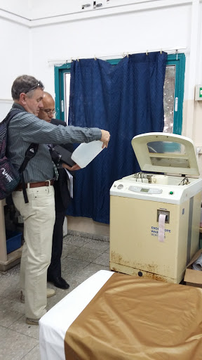

Photo: A very old AER [automated endoscope reprocessor] as evidenced by the rust on the bottom of the machine. But it is the only one they have.

Comments and Main Recommendations
- First and foremost I was very impressed by the dedication, humour and enthusiasm of all the staff I met, in the face of enormous problems and hardship.
- Water quality was a major issue for all concerned, in addition to the lack of basic supplies such as soap and detergents for the machines.
- Staff shortages both in terms of numbers and skill are of a major concern to all departments.
- The equipment is mostly old requiring engineering intervention on a daily basis; no time for planned maintenance or validation of the processes used.
- The surgical instruments are of poor quality and in an ideal world should be replaced.
- The infrastructure and fabric of the departments I visited were in a very poor state and the basic cleanliness of the units left much to be desired.

Short term recommendations | Long term recommendations
Look to improve overall cleanliness of the central sterilisation series unit Restrict unnecessary access and movement of people within the units. Refreshments should be banned from these areas. | Provide an appropriate Central Sterile Service Department built to required standards, which will cater for all the sterilising of instruments for Shifa Hospital. This would provide economies of scale and also provide a trained cadre of staff.
Attempt to improve water quality i.e. desalination unit | Water quality improvement
Procurement of sufficient and reliable supply of appropriate detergent & enzymatic detergent, so that the newly purchased washer-disinfectors can be put into operation. | Purchase of new autoclaves with planned maintenance
Upgrading knowledge and skills of sterilisation through on-job training | Planned replacement of surgical instruments  Institute an accredited training programme to ensure a supply of fully trained staff.

2. Infection control
Whilst at Shifa I had the opportunity to meet with Mousa Al Amawi [MoH Head of Infection Prevention Control]; Mahmoud Udah [Head of Quality Control & Infection Prevention, Shifa]; Microbiology Department and the Intensive Care Unit.
Meeting with Mousa Al Amawi
- Mousa worked for some 20 years in Saudi Arabia before arriving in Gaza in 2009. Since then he has instigated a 15 month Diploma Course in Infection Control, aided by Professor Osama Raslan from Egypt, via a video conference. Thirty persons did the course of whom 8 are employed at Shifa.
- Mousa is well aware of the many infection control problems both in Gaza and in Shifa. The main problem is to get everyone, from the top down, to buy into the whole concept of infection control.
- Shifa does have an infection control committee headed by Mahmoud Udah and an infection control team under the leadership of Mahmoud. This is made up of four nurses.
- There appears to be little, if any, accurate data collection and use, of infection rates
- There are no antibiotic policies or guidelines [antibiotic supple is subject to disruption]
- There is concern about antimicrobial resistance [note people of Gaza can purchase antibiotics over the counter at pharmacists]
- Overall shortage of numbers of sinks and hand washing facilities in general.
Meeting with Mahmoud Udah
- He underlined and echoed the concerns expressed by Mousa. Shifa does have an infection control committee which meets monthly. However I was uncertain as to its role and function. It did not seem to develop strategies of infection control in Shifa.
- They do not have accurate microbiological data due to the capability gaps in the Microbiology Department [see below].
- The infection control team of four nurses is too small for the size of Shifa.
- He welcomed the construction of the new surgical wing with its modern air conditioned theatres but lamented the fact that the Intensive Care Unit had only one sink for seven beds.
Microbiology Department
- Occupied a very small part of the Clinical Pathology Unit, restricted to just one room, which access to another shared facility.
- They have two incubators but no carbon dioxide to encourage growth of pathogens such as pneumococcus, haemophilus, neissseria; no anaerobic capability to grow pathogens such as clostridia or bacteroides.
- They receive some 40-50 specimens per day, which for a 740-bedded hospital is an extremely small number.
- They also receive 20 infection control specimens per day. Unsure as to what these actually were.
- They have no Class II safety cabinets so Tb culture is sent elsewhere.
- Blood culture bottles and agar plates are made on site.
- Currently there is a shortage of plastic petri dishes.
- Identification is performed by morphology alone; unable to identify MRSA.
- No control strains.
Intensive Care Unit
- This is housed in the new surgical block.
- There is a severe shortage of suitably trained staff. The nurse: patient ratio is 1;3/4. It is a 9-bedded unit but only 3 occupied. They have very strict admission criteria because of this.
- The admit some 900 patients per year of whom 60% are surgical and 40% medical.
- There is a sink in each of the two single cubicles but none outside. There is only ONE sink for the remaining seven beds and this is sited away from the patients in a corner behind the nurse’s station.
- There are hand rub dispensers but not hand rub liquid available.
- They have had outbreaks with antibiotic resistant strains of Acinetobacter, Klebsiella and E. coli. Unit was never closed.
- Discharged patients as soon as possible.
- Unsure as to how or whether these outbreaks were ever brought under control.
- Whilst there I witnessed multiple breaches in infection control – no attempt to hand wash either before or after touching the patient; much touching between members of staff; repeated manipulation of medical devices attached to the patient again without hand decontamination.

Comments and Main Recommendations
- Infection control at Shifa is rather rudimentary. There is a real shortage of trained staff and both the Infection Control Committee and Infection Control Teams are re-active not pro-active.
- There are no antibiotic policies or guidelines in place.
- The Microbiology Department is woefully inadequate for the needs of Shifa, though I recognise that some of the deficiencies are caused by factors outwith of Gaza. In its current format it is unable to provide the ICT or ICC with accurate data. As a result no proper surveillance occurs.
The key word is PREVENTION. There is an urgent need for senior members of management and clinical staff, medical and nursing, to buy into the whole concept of infection control. Infection control is everyone’s responsibility. Infections delay patient recovery and can in some instances prove fatal. Infections are expensive both in financial aspects but also in time. Recovery is delayed and beds are blocked.

Short term recommendations | Long term recommendations
Empower the ICT and ICC to improve the standing and raise the profile of Infection Control. ICC to review its purpose and function. The Executive at both MoH and Shifa must support this. | Infection Control is as much about changing behaviour as science. Essential that the Gaza MoH and Shifa senior management buy into the concept on a permanent basis. It will be a long and difficult road, but along the way I am sure that MAP can provide guidance and assistance, which will be of benefit. It is what the people of Gaza should reasonably expect to receive.
The ICT should perform audits, starting with hand washing. Findings must be fed back to those observed with recommendations on how to improve compliance. An example of such a audit is attached (Annex 1).
Encourage clinicians to provide antibiotic policies or guidelines. Essential they own these policies and are followed to the letter.
To explore ways of improving the quality of microbiology for Shifa

ANNEX 1

